Web : www.jntuh.ac.in  E Mail : dejntuh@jntuh.ac.in  Phone : Off: +91–40–23156113 Fax : +91–40–23158668 | 
JAWAHARLAL NEHRU TECHNOLOGICAL UNIVERSITY HYDERABAD
(Established by JNTU Act No. 30 of 2008)
Kukatpally, Hyderabad – 500 085 Telangana (India)
ACCREDITED BY NAAC WITH ‘A’ GRADE

Dr. V. Kamakshi Prasad
M.Tech., Ph.D. (IIT-M),FIE.,MIEEE,MCSI,LMISTE
Professor of Computer science and Engineering&
DIRECTOR OF EVALUATION

Lr.No.DE / JNTUH / All Courses / Special Suppl.Exams. JAN/FEB-2019, Date: 27-11-2018.

To

The Principals of

JNTUH Constituent and Affiliated Colleges

Sir,

Sub: JNTUH, Hyderabad - Examination Branch – All U.G. and P.G. courses – Special Supplementary Exams, Jan/Feb-2019- Notification - Instructions to the Principals–Reg.

* * * * *

The Principals of the constituent and affiliated Colleges are hereby informed that the University Examination Branch issues notification for the conduct of Special Supplementary examinations during Jan/Feb -2019 for the candidates who were admitted into B.Tech(Reg.), B.Tech(CCC), B.Tech.(PTDC), B.Tech.(FDH), B.Pharmacy, M.Tech.(Reg.), M.Tech.(PTPG), M.Tech.(SSS), M.Tech.(CCC), M.Sc(Reg.), M.Sc.(Part time), M.B.A.(Reg.), M.B.A.(Part time), M.C.A.(Reg.) and all other Under-Graduate and Post-Graduate courses, to clear backlog subjects so as to secure the required credits / to satisfy the academic requirement to get their degrees. This last chance is for the candidates who have completed their class work (double the duration of the course) and who have availed 2 years extra time to clear backlog subjects could not clear the subjects.

Please inform the students that this notification is meant for the students studied in the constituent and affiliated colleges of JNTUH Hyderabad only.

The Principals are requested to note the following instructions.

1. Every college has to make the consolidated Exam. Registration fee for all the above examinations in the form of a single RTGS / NEFT / GRPT Transfer to the Registrar’s Bank Account No.62079988622 (State Bank of India, JNTUH Campus Branch, IFSC/RTGS/GRPT Code: SBIN0021008). The Principals are requested not to retain any amount from the examination registration fee as the examinations will be conducted at JNTUH College of Engineering Hyderabad, kukatpally, Hyderabad- 500085.

- Different deadlines for schedule of events and other details are mentioned here under.

STUDENT REGISTRATIONS SCHEDULE
EVENT | Start date for students to  Register for Spl Supply. Exams  (at respective colleges | Last date for students to  Register for Spl Suppyl. Exams  (at respective colleges) | Date for Consolidated Fees Payment (Single RTGS transfer )
Exam Registration Without Late Fee | 04-12-2018 | 18-12-2018 | 29-12-2018
Exam Registration With Late Fee of Rs.100/ | 19-12-2018 | 24-12-2018
Exam Registration With Late Fee of Rs.1000/- | 25-12-2018 | 28-12-2018
 |  |  |  | Page 1 of 9

SCHEDULE OF THE EVENTS


Submission of Hard copy of Application forms along with RTGS payment | On or before
receipt to the Controller of examinations JNTUH | 03-01-2019
.

3. If the supplementary students of any closed college are attached to your college, the application from one-time-chance students of such colleges should also be accepted at your college

4. If the college is closed and the supplementary students are not attached to any college, such students may be guided to consult ACE(Academic) for necessary assistance in connection with submission of their examination application forms

5. The candidate’s data relating to the Special Supplementary Examinations, Jan/Feb - 2019, should be uploaded to the Examination Portal on or before 31-12-2018 in the Excel template ( Excel template file will be available in the portal) using the URL, http://registrations1.jntuh.ac.in/onetimechance. The latest photograph of the candidate should be uploaded to the Examination Portal using the appropriate menu service, Admin options upload photos.

6. The Principals are hereby informed, by direction, if award lists of the Lab Examinations and hard copy are not received by the University examination branch on or before the scheduled date, absent will be shown in result and no correction will be entertained later. The Principals are informed to appoint the examiners for conducting special supply lab exams for these students from the same clusters which are specified for Regular/Suppl. Examinations of November. 2012 It is for instructed to submit End Laboratory marks to the Controller of examinations JNTUH ( please see the enclosed ANNEXURE).

7. Answer scripts of the Malpractice cases and court cases (if any) are to be kept in a separate sealed cover and sent to Dr B Ravinder Reddy, Addl. Controller of Examinations, Examination Branch, JNTUH, Kukatpally, Hyderabad-500085 and such cases are to be reported as Malpractice Cases / Court Cases in D-form.

8. Notifications for the above examinations are enclosed along with this letter. The Principals are requested to display the same in the student notice board and inform to the students of concerned college without fail.

9.The cooperation of the Principals is highly solicited for the smooth conduct, processing and early declaration of examination results.

Yours sincerely,

Sd/-

DIRECTOR OF EVALUATION

Copy to:

CE, All ACEs,

All UG/PG. Affiliated Colleges (through portal),

AR (EXAMS), SDC Section, Concerned Seat Clerk

Encl: ANNEXURE

Page 2 of 9
JAWAHARLAL NEHRU TECHNOLOGICAL UNIVERSITY HYDERABAD

KUKATPALLY – HYDERABAD – 500 085.


EXAMINATION BRANCH

NOTIFICATION FOR
SPECIAL SUPPLEMENTARY EXAMINATIONS

B.Tech(Reg.), B.Tech(CCC), B.Tech.(PTDC), B.Tech.(FDH), B.Pharmacy, M.Tech.(Reg.), M.Tech.(PTPG), M.Tech.(SSS), M.Tech.(CCC), M.Sc(Reg.), M.Sc.(Part Time), M.B.A.(Reg.), M.B.A.(Part Time), M.C.A.(Reg.), and all other Under-Graduate and Post-Graduate courses
[for the candidates who have completed their class work (double the duration of the course) and who

have availed 2 years extra time to clear backlog subjects]

The Candidates appearing for the above examinations which are to be conducted in Jan/Feb-2019 are informed to note schedule given below

EXAM REGISTRATION | START DATE | END DATE
Without Late Fee | 04-12-2018 | 18-12-2018
With late Fee Rs. 100/- | 19-12-2018 | 24-12-2018
With late Fee of Rs.1000/- | 25-12-2018 | 28-12-2018

Important Note: Applications will not be accepted after 28-12-2018.
Detailed Time Table of Theory Exams will be notified in JNTUH Website

(www.jntuh.ac.in)

EXAMINATION FEE

FOR EACH SUBJECT (THEORY/PRACTICAL ) | Rs. 400/-

- This Notification is meant for the students who studied in the constituent and affiliated colleges of JNTUH Hyderabad only.

- This Notification is issued for the candidates who have completed their class work (double the duration of the course) and who have availed 2 years extra time to clear backlog subjects, who could not complete for the award degree.

- A common application form for all the courses is available in the website, which is to be filled by the candidates giving all the details without fail. A separate application is to be submitted for each semester.

- Applicants should enclose the photocopies of latest marks memo containing failed subjects along with syllabus copy the application without fail.

- The duly filled in applications should be handed over in the college office with necessary fee.

- The Principals are requested to submit the filled in applications to the Controller of Exams, Examinations Building, JNTUH, Hyderabad on or before 03-01-2019 without fail.

- Lab/ Project Viva examinations are to be conducted at the respective colleges during 10-01-2019 to 16-01-2019 and the Award Lists are to be sent to Dr.S Tara kalyani, Controller of Examinations, JNTUH, Kukatpally, Hyderabad – 500 085 so as to reach this office on or before 21-01-2019.

DATE: 27-11-2018 Sd/-
DIRECTOR OF EVALUATION

Copy to:

CE, All ACEs, Coordinator,
All NODAL CENTERS, All UG/PG . Affiliated Colleges (through portal),
JR (Exams),AR (EXAMS), SDC Section, Concerned Seat Clerk

Page 3 of 9

Hall Ticket No: |  |  |  |  |  |  |  |  |  |  |  |  |  |  |  |  |  |  |  |  |  | College
 |  |  |  |  |  |  |  |  |  |  |  |  |  |  |  |  |  |  |  |  |  | Code

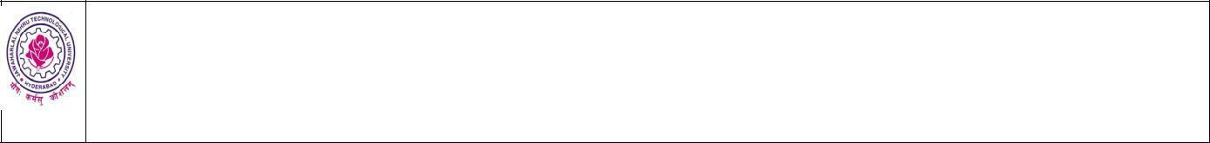
JAWAHARLAL NEHRU TECHNOLOGICAL UNIVERSITY HYDERABAD

KUKATPALLY – HYDERABAD – 500 085

Application for Registration of______________________________ Spl.Supply.Exams Jan/Feb-2019

(Course)
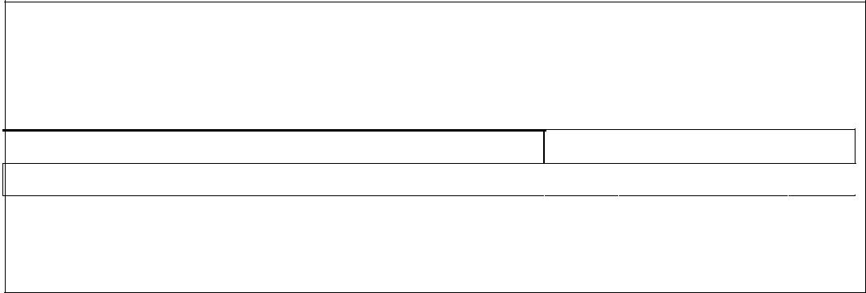

- Enclose a photocopy of the marks memo containing backlog subjects.

- Enclose a photocopy of the syllabus of backlog subjects.
- Candidate has to submit separate application for each semester examination,

- Tick [√ ] appropriate box of the regulation (OOR/OR/NR/RR/R05/RO7) under which you are appearing for the subject(s).

Branch Regulation
OOR OR NR RR R05R07

Exam:

________________________________________________________________________________________________________

(enter the name of the examination as shown in the photocopy of the marks memo, enclosed)

Affix a recent

Passport size

photograph.

Centre of Examinaitons: JNTUH College of Engineering Hyderabad, Kukatpally,

Hyderabad – 500085

(in case of change of center that will be informed in the Hall tickets)

Name

In Block Letters

Father’s

Name

Address for
Communication
(Do not repeat your
name)
Contact No (Cell/Phone): |  | Pin Code:
(Tick [√ ] the appropriate box) Sex: | Male | Female

Write the “Subject code” and “Subject Name” by referring to your Marks Memo containing the failed subject(s).

Also, enclose a photo‐copy of the marks memo.


S.No. |  | Subject |  | Subject Name |  | S.No. |  | Subject |  | Subject Name
S.No. |  | Code |  | Subject Name |  | S.No. |  | Code |  | Subject Name
01. |  |  |  |  | 05.
02. |  |  |  |  | 06.
03. |  |  |  |  | 07.
04. |  |  |  |  | 08.

Certified that the above information is CORRECT and FILLED by ME.

Signature of College Principal with seal Signature of the Candidate.
Page 4 of 9

Instructions to the candidates:-

- For fee particulars refer “Examination Notification”

- Candidates are instructed to be very careful about the entries to be made. All entries should be in candidate’s own handwriting. Candidate will be held responsible for any incorrect entry that he/she makes.
- The University reserves the right to cancel the registration of the candidate at any stage when it is detected that his/her admission to the examination.

- Any false or incorrect statement in the application will render the candidate liable to disciplinary action.

- The application should be submitted through the Principal/Head of the respective college/unit.


Duplicate Hall Tticket

Hall Ticket No: |  |  |  |  |  |  |  |  |  |  |  |  |  |  |  |  |  |  |  |  |  | College
 |  |  |  |  |  |  |  |  |  |  |  |  |  |  |  |  |  |  |  |  |  | Code

JAWAHARLAL NEHRU TECHNOLOGICAL UNIVERSITY HYDERABAD

KUKATPALLY – HYDERABAD – 500 085
Application for Registration of_______________________________ Spl.Supply.Exams Jan/Feb-2019 (Course)

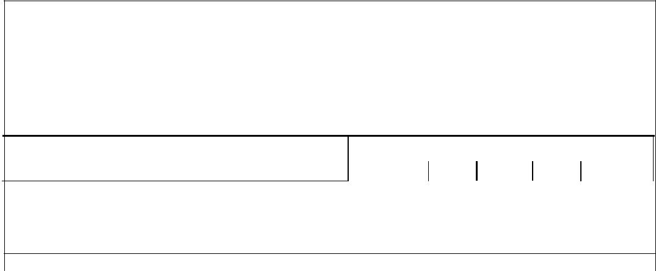

- Enclose a photocopy of the marks memo containing backlog subjects for which you are registering.

- Enclose a photocopy of the syllabus of backlog subjects for which you are registering.

- Candidate has to submit separate application for each semester examination,

- Tick [√ ] appropriate box of the regulation (OOR/OR/NR/RR/ R05) under which you are appearing for the subject(s).

Branch |  | Regulation
 |  |  | OOR | OR | NR RR R05 R07

Exam:

________________________________________________________________________________________________________

(enter the name of the examination as shown in the photocopy of the marks memo, enclosed)

Affix a recent

Passport size

photograph.

Centre of Examinaitons: JNTUH College of Engineering Hyderabad, Kukatplally,

Hyderabad – 500085

(in case of change of center that will be informed in the Halltickets)

Name:

Father Name:

(Tick [√ ] the appropriate box) Sex: Male Female

Write the “Subject code” and “Subject Name” by referring to your Marks Memo containing the failed subject(s). Also, enclose a photo‐copy of the marks memo.


Subject |  |  | Subject
S.No. | Subject Name | S.No. | Subject Name
Code |  |  | Code
01 |  | 05
02 |  | 06
03 |  | 07
04 |  | 08
ASST. REGISTRAR (EXAMS.) | PRINCIPAL |  | CONTROLLER OF EXAMINATIONS

Page 5 of 9

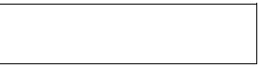
Orginal Hall Ticket

Hall Ticket No: |  |  |  |  |  |  |  |  |  |  |  |  |  |  |  |  |  |  |  |  |  | College
 |  |  |  |  |  |  |  |  |  |  |  |  |  |  |  |  |  |  |  |  |  | Code

JAWAHARLAL NEHRU TECHNOLOGICAL UNIVERSITY HYDERABAD

KUKATPALLY – HYDERABAD – 500 085

Application for Registration of_______________________________Spl.Supply.Exams Jan/Feb-2019 (Course)

- Enclose a photocopy of the marks memo containing backlog subjects for which you are registering.

- Enclose a photocopy of the syllabus of backlog subjects for which you are registering.

- Candidate has to submit separate application for each semester examination,

- Tick [√ ] appropriate box of the regulation (OOR/OR/NR/RR/ R05/R07) under which you are appearing for the subject(s).

Branch |  | Regulation
 |  |  | OOR | OR | NR RR R05 R07

Exam:

________________________________________________________________________________________________________

(enter the name of the examination as shown in the photocopy of the marks memo, enclosed)

Affix a recent

Passport size

photograph.

Centre of Examinations: JNTUH College of Engineering Hyderabad, Kukatplally,

Hyderabad – 500085

(in case of change of center that will be informed in the Halltickets)

Name

Father Name

(Tick [√ ] the appropriate box) Sex: Male Female

Write the “Subject code” and “Subject Name” by referring to your Marks Memo containing the failed subject(s). Also, enclose a photo‐copy of the marks memo.

Subject |  |  | Subject
S.No. | Subject Name | S.No. | Subject Name
Code |  |  | Code
01 |  | 05
02 |  | 06
03 |  | 07
04 |  | 08
ASST. REGISTRAR (EXAMS.) | PRINCIPAL |  | CONTROLLER OF EXAMINATIONS
Note : Read instruction carefully:

All candidates should be present in the Examination Hall 15 minutes before the time of commencement of Examinations.

No student will be allowed after the time at which the Examination commences.

Candidates are prohibited from bringing any book, notebook or loose sheets of papers to the Examination Hall. If they do so, they are liable for expulsion from the Examination Hall. Candidates are not allowed to use any book or books nor allowed to keep a book or part thereof, or paper of any kind with them. Candidates are also prohibited from bringing their own mathematical tables into the Examination Hall. These will be supplied to the candidates by the Chief Superintendent upon request when answering papers in Mathematics and Science subjects. Mathematical instruments will however be allowed to be brought in. They are also prohibited from talking to each other, copy or communication with a person outside the Examination Hall. If a candidate is found violating these rules and/or committing any other malpractice and/or behaving indisciplined manner or causing nuisance or disturbance to the other candidates, he/she will be expelled from the Examination Hall. He/She will not be allowed to sit for the remaining papers and he/she will be punished as per the University malpractice rules. Candidates are permitted to bring Electronic Calculators into the Examination Hall.

Candidates have to bring their Hall Tickets along with them every day. They should also bring the Identity card issued by the college for verification.
Page 6 of 9

ANNEXURE

INSTRUCTIONS FOR SUBMISSION OF

LAB MARKS OF EXTERNAL EXAMINATIONS

- The format for AWARD LIST (for Laboratory Examinations) is given and a sample copy is enclosed.

- The AWARD LISTS for each laboratory examination must be prepared by the examiners, in DUPLICATE (carbon copy only).

- Original copy of the AWARD LIST along with “Statement of attendance” should be handed over to the Chief Superintendent of examinations, in a sealed cover. This sealed cover is to be sent to Dr S TARA KALYANI, Controller of Examinations, JNTUH, Kukatpally, Hyderabad-500085, by Registered Post.

- Duplicate copy of the AWARD LIST along with photo-copy of “Statement of attendance” should also be handed over to the Chief Superintendent of examinations, in a sealed cover. This sealed cover is to be kept in the safe custody of the Principal.

- The format for STATEMENT OF ATTENDANCE FOR LABORATORY EXAMINATIONS is enclosed.

- The following details should be written / printed on the sealed covers (It is advised

to have 9″ x 4″ size envelopes with the following format printed on them)

Name of the College : ______________________College Code : ________

Name of the Exam Name of Branch

: ______________________ Regulations: ________ (Write OOR or OR or NR or RR or R05 or R07) : _____________________ Branch Code: ________

Name of Laboratory : _____________________________________________

Date(s) of Lab Exam: _____________________________________________

Signature of Examiner-1: _________________________________________

Signature of Examiner-2: _________________________________________

Page 7 of 9

Jawaharlal Nehru Technological University Hyderabad, Hyderabad - 500 085

Name of the Affiliated College | College Code

AWARD LIST (for Laboratory Exams.)

Name of Examination: ____________________________ (Reg/Supp) _______________ 2019

Branch: __________________________________________________ Regulations: _____________

Name of Laboratory: ________________________________________________________________

Date of Lab. Examination: __________________________ Maximum Marks: _____________

Name of Examiner-1: _______________________________________________________________

Name of Examiner-2: _______________________________________________________________

Note: (1) Please enter the marks in the serial order of the Hall Ticket Numbers of the students.

- If there is a break in the serial order of the Hall Ticket Numbers, kindly draw a line.

- The award list(s), in duplicate, must be submitted to the Chief Superintendent of the Examinations along with “statement of attendance” in two sealed covers.
 | Hall Ticket Number of | Marks | Marks awarded (in words)
Sl.No. | Hall Ticket Number of | in
Sl.No. | the student | in | First digit | Second digit
 | the student | figures | First digit | Second digit
1
2
3
4
5
6
7
8
9
10
11
12
13
14
15

Note: Every correction must be with an initial by any one of the Examiners.

Total number of corrections (in words): _______________ only.

Signature of Examiner-1 Signature of Examiner-2

Page 8 of 9
Jawaharlal Nehru Technological University Hyderabad, Hyderabad - 500 085


Name of the Affiliated College College Code

STATEMENT OF ATTENDANCE FOR LABORATORY EXAMINATIONS

Name of Exam: ________________________________________ Regulations:________________

Branch: ____________________________________________________ Branch Code: _________

Name of Laboratory: ________________________________________________________________

Date(s) of Exam: ____________________________________________________________________

Hall Ticket Numbers of candidates registered :

No. registered: | No. absent: | No. present:
* Absentees are rounded in RED ink
SIGNATURE OF EXAMINER-1 |  | SIGNATURE OF EXAMINER-2
SIGNATURE OF |  | SIGNATURE OF
HEAD OF DEPARTMENT |  | CHIEF SUPERINTENDENT

Page 9 of 9

